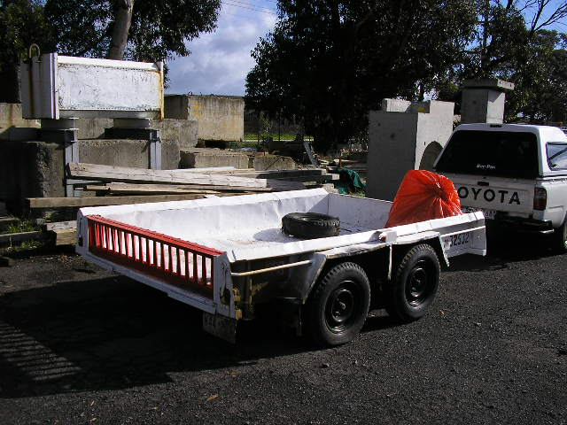 | Hazard Information Sheet
  Equipment: | Trailers
 | Equip Type: | Tandem Trailer
 | Generic Description or  Specific Make / Model: | Tandem Trailer
 | Type:
 | Other Details

Operator Requirements: | Operators must be trained and competent to use this equipment safely.
Purpose For Which This Equip Is Designed: | A large trailer with mounted winch to ensure easier loading

Hazards & Risks:
Control Measures:
Crushing (Squashing):  Equip fishtailing and rolling over if towed too fast esp. around corners | When being towed, driver to tow machine relative to road condition and never exceed 80km/h
Striking:  Equip rolling away and hitting bystanders etc | Operator to apply hand brake and chock wheel as appropriate.  When towing always connect safety chains
Losing load while using manual winch | Operator to ensure load properly secured and free of obstruction while winching onto tariler
Risk of load toppling if not secured properly | Operator to ensure load properly secured using appropriate ties
Entanglement:  Risk of getting caught in winch cogs/gears | Guard present over gear winch.  Operator to ensure safe working area and no loose clothing etc

Disclaimer: In fulfilment of its statutory obligations, (ARS) & John Holland has taken what it considers to be all reasonable precautions and exercised due diligence to ensure that it has provided all relevant information on the safe use of the plant. However, except as required by law and only to the extent so required, (ARS) & John Holland does not make any representation, warranty or undertaking, express or implied, as to, or accept any responsibility or liability for, the accuracy or completeness of, or any errors in or omissions from, this Hazard Information Sheet. Except as required by law and only to the extent so required, neither (ARS) & John Holland nor any of its respective directors, officers, agents, or employees shall in any way be liable directly or indirectly to any person or body for any loss or damages, costs or expenses whatever arising out of or in connection with the information contained in this Hazard Information Sheet. | Date: 19/06/06

